*Easter Sunday ~ April 20, 2025*

***Mass Schedule and Intentions:***

Sunday, April 20th – 8:00am *(Rosary at 7:30am) – Easter*

For the Parishioners

Thursday, April 24th – 5:30pm

*(Adoration & Confession beginning at 5:00pm)*

*+* Ray & Jo McLaughlin

Sunday, April 27th – 8:00am *(Rosary at 7:30am) – Easter*

For the First Communion Class

Sacred Heart Catholic Church

Sacred Heart Mission: We, the Sacred Heart Catholic Church parish, are a community of Christian faith striving to teach the word of God, to minister the sacraments, and to share Jesus’ love.

**SACRED HEART UPCOMING EVENTS:**

**THURDAY, APRIL 24th** – Knights of Columbus Meeting

**SUNDAY, APRIL 27th –** First Communion

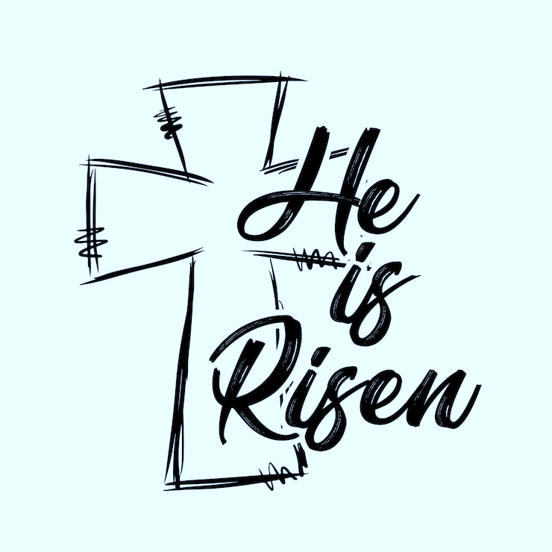

**JOIN US** for coffee, rolls, and fellowship after Mass. All are welcome!

**EASTER SUNDAY –** In the second reading today, St. Paul reminds the Colossians that they have been raised with Christ, exhorting them to “be intent on the things above rather than on things of earth.”  We, too, have been raised with Christ.  Let us rejoice and be glad!

**GOD BLESS** Gunnar & Kiara O’Brien who are being baptized today.

**EUCHARISTIC MINISTERS –** Both current and new Eucharistic Ministers will be commissioned today during Mass.

**KNIGHTS OF COLUMBUS** will meet THIS Thursday, April 24th, in the Sacred Heart Parish Center at 6:30pm.

**FIRST COMMUNION** is NEXT Sunday, April 27th.  We have seven students making their First Communion – Claire Abell, Lilianna Grant, Laryssa Nelson, Wade Paulsen, Delany Sturges, Kael Sullivan, and Breckyn Williams. Please keep them in your prayers.

**PARISH COUNCIL MEETING** will meet on Thursday, May 1st, after Mass.  It is time for election of new council members.  Anyone wanting to run for the council should let the office know: [h.cahalan@sacredheartparish.org](mailto:h.cahalan@sacredheartparish.org).  It is a 3-year term, and you can serve 2 terms. Council members whose terms are up this year are Jim Rooney, Colleen Barnes, and Tony Laudner.

**IRISH FAIR** was a success again this year.  We have a profit of $18,560.38.  We have yet to pay gambling tax, which is around $800.00.  Income/Expense Reports for the fair are on the table going into the Parish Center.  Thank you to everyone who planned or worked or donated to the fair in anyway.  The money will go towards the Religious Education programs in our parish.

**HARMONIES CONCERT –** Zion St. John Lutheran Church in Sheffield is hosting the Harmonies Concert on Sunday, May 4th, at 3:00pm.  Refreshments to follow.  Brochure on bulletin board.

**FOOD BANKS –**The need never ends. ***West Fork Food Pantry:***If you or someone you know is in need, their hours are Thursdays from 2:00pm–5:00pm and the first Saturday of the month from 10:00am–12:00pm.  They are located on Main Street in Sheffield.  Their phone number is 641-892-4010.  You must be a resident of the West Fork School District to be eligible for receiving food.***Hawkeye Harvest Food Bank***is always in need of donated items.  There are baskets in the entry to the church to leave any items you want to donate.

**WORLDWIDE MARRIAGE ENCOUNTER –** Is it time to disconnect from the world and reconnect with one another? Busy lives can take away from our relationships. Put your relationship on track for more communication, love and harmony. The upcoming weekend dates this week on April 25th–27th in Epworth and September 12th–14th in Dubuque.  For more information, call Denise and Greg at 563-608-3305 or register at [wwme.org](http://wwme.org/).

----------------------------------------------------------------------------------------------------------------------------------------------------------------------------------------------

      With Gratitude We Give   

|  |  |  |  |  |  |  |
| --- | --- | --- | --- | --- | --- | --- |
| **BUDGET** | **April 13, 2025** | | **BUILDING FUND** | | **CHURCH ROOF FUND** | |
| Adults: | | $1,940.00 | Balance: | $**15,770.97** | Balance: | **$27,912.60** |
| Online (2x/month): | | $0.00 | Donations: | $150.00 | Donations: | $0.00 |
| Offertory: | | $124.00 | **TOTAL**: | **$15,920.97** | **TOTAL**: | **$27,912.60** |
| Building: | | $150.00 |  |  |  |  |
| Church Roof: | | $0.00 |  |  |  |  |
| **TOTAL:** | | **$2,214.00** |  |  |  |  |

----------------------------------------------------------------------------------------------------------------------------------------------------------------------------------------------

      Religious Education News   

**TODAY –** No class for Easter Sunday. ***No Donuts***

**SUNDAY, APRIL 27th –** First Communion. They will greet before Mass. ***Donuts****: Kollman/Reimers & McLaughlin Families*

*\*\*\*Donuts – For the second half of the year, donuts will be purchased by the Guild. Families are needed to help serve and clean up.*

|  |  |
| --- | --- |
| **SUNDAY, APRIL 20, 2025 – 8:00am – Easter Sunday**  LECTOR:  Steve Abbas  EUCHARISTIC MINISTERS:  Sarah & Paige Johnson                                                  Renee Laudner, Lisa Schultz  MUSIC:  Easter Choir  SERVERS:  Crayton Dick, Carter Weatherford  GREETERS/USHERS: Dale & Bonnie Hubka  MONEY COUNTERS:  Jill Rowe, Colleen Pearce  ROSARY:  Jeff Schultz | **SUNDAY, APRIL 27, 2025 – 8:00am – First Communion**  LECTOR:  Sue McLaughlin  EUCHARISTIC MINISTERS:  Tim & Margaret Nuehring                                                  Jim Weaver, Dave Weiland  MUSIC:  Kim Tracy, Ann Wolf  SERVERS:  Makenna Dick, Brelynn & Kynnley Nelson  GREETERS/USHERS: First Communion Class  MONEY COUNTERS:  Jim Rooney, Paul Rowe  ROSARY:  Charley Sprung |
| **SUNDAY, MAY 4, 2025 – 8:00am**  LECTOR:  Jill Rowe  EUCHARISTIC MINISTERS:  Kate Osterman, Pat Sheldon                                                  Jim Weaver, Dave Weiland  MUSIC:  Kaleb Hrubetz, Ann Wolf  SERVERS:  Makenna Dick, Cece McLaughlin  GREETERS/USHERS: Brad & Mary Shupe  MONEY COUNTERS:  Jill Rowe, Sheri Sprung  ROSARY:  Bill Martin | **SUNDAY, MAY 11, 2025 – 8:00am – Mother’s Day**  LECTOR:  Lisa Schultz  EUCHARISTIC MINISTERS:  Jan Abbas, Amanda Dick                                                 Tammy Hrubetz, Renee Laudner  MUSIC:  Kim Tracy, Ann Wolf  SERVERS:  Sophie Grant, Norah Hubka  GREETERS/USHERS: Brad & Mary Shupe  MONEY COUNTERS:  Tom Madden, Charley Sprung  ROSARY:  Les Knowles |

----------------------------------------------------------------------------------------------------------------------------------------------------------------------------------------------

**Pastor:** Fr. Josh Link: 641-822-4950 (Rockwell), 641-357-3214 (Clear Lake)

**Council President:** Tony Laudner: 641-530-2583, tlaudner@clearlakeschools.org

**Building Committee Co-Chairs:** Tim Nuehring: 641-430-4905, tim.nuehring@heftyseed.com; Gary Weiner: 641-425-1217

**Finance Committee Chair:** Jane Weiland: 641-512-5861

**Bookkeeper/Guild President:** Helen Cahalan: 641-822-4852, h.cahalan@sacredheartrockwell.org

**Coordinator of Religious Education:** Sarah Nelson: 641-512-7970, [dbq173ff@dbqarch.org](mailto:dbq173ff@dbqarch.org)

**Director of Music:** Ann Wolf: 641-583-3647, ann.maywolf@gmail.com

**Bulletin:** Items for the bulletin? Email sacredheartrockwellbulletin@gmail.com or call Sarah Johnson: 641-425-4896. Items due Thursday by 12:00pm!

** FOLLOW US ON FACEBOOK!**  Look for Sacred Heart Catholic Church Rockwell