December 21, 2025
Mass Schedule and Intentions:
Sunday, December 21st – 8:00am (Rosary at 7:30am)
+ Tom Wolf
Wednesday, December 24th – 6:00pm
(Adoration & Confession beginning at 5:00pm)
+ Gary & Sheryl Weiner
Thursday, December 25th – No Mass
Sunday, December 28th – 8:00am (Rosary at 7:30am)
+ Sue Eckenrod
Sacred Heart Catholic Church
Sacred Heart Mission: We, the Sacred Heart Catholic Church parish, are a community of Christian faith striving to teach the word of God, to minister the sacraments, and to share Jesus’ love.

SACRED HEART UPCOMING EVENTS:
SUNDAY, DECEMBER 21st – Christmas Program and Potluck
***See backside for Christmas Mass Schedule

JOIN US for the Religious Education Christmas Program after Mass. Following the program will be the potluck. There will be cookie decorating and a hot chocolate bar, as well! All are welcome!

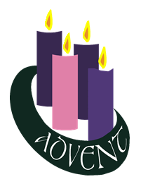
WHY IS IT IMPORTANT TO CELEBRATE CHRISTMAS? As we celebrate the birth of our Lord Jesus Christ, I think it is also appropriate to ponder the very question of what we are doing. If we ponder it, we could actually come to a much deeper understanding and even strengthen our reasons for why we are even Christians. It is important to celebrate Christmas, not just because of the marketing exposure, the Hallmark movies, or all the gifts that are shared. It is important to celebrate Christmas because of Love. We hear in John 3:16 “For God so loved the world that he gave his only begotten Son, so that everyone who believes in Him might not perish but might have eternal life.” This is why Jesus came into the world, so that we might have eternal life. God sent us His son out of His great Love for us, plain and simply. As a response, we should embrace His love and share His love. May everything we do this Christmas season be done out of Love. Love for God, love for your neighbor, and also love for ourselves. May God bless you all during this great season of Love! I wish you all a very Merry Christmas and I hope you all experience God’s love for you in a new and special way this year! ~ Fr. Joshua Link

FOURTH SUNDAY OF ADVENT – When he discovered that Mary was with child, Joseph resolved to end their engagement with as little disgrace as possible. But obedient to the voice of God, he changed those plans and became instead the protector of the child Jesus and His mother Mary. God grant that I may be as open to the leading of the Holy Spirit!

FLOWERS NEAR THE ALTAR ARE IN LOVING MEMORY OF Jim & Renee Martin, Dan Cahalan; Ray, Jo, & Joanie McLaughlin, rren & Helen Wagner; Gary & Sheryl Weiner; Joshua Knowles; Adam Hanig; Tom Wolf, George Scholl family; Deceased loved ones; Roger Sido, Andy Frascht, & Jeanette Leyen; Cahalan & Kuennen families; Francis & Loyola Scholl, John & Doris Degen, Jack Degen; Ambrose & Elvira Rooney, Sue Eckenrod. If anyone would like to donate towards flowers for the Christmas season, please put the money in the collection and if in memory or honor of someone, leave a note with your donation.

CHRISTMAS CAMPAIGN – The items for our Northern Lights Men’s Shelter Christmas Campaign are due back today. The committee will be getting the baskets ready to be delivered this week. Thank you for your generosity!

CHRISTMAS CHOIR – We will have a short practice TODAY immediately after the program and potluck.

CHRISTMAS DECORATING – Help needed TODAY to carry trees into the church and bring down bins and decorations from the choir loft. We will be decorating the church TOMORROW, Monday, December 22, at 1:30pm (note new time). You are invited to come bring your ideas/lend your talents to make our church festive for the Christmas season!

PARISH BOOKS will close December 31st per Archdiocese of Dubuque Stewardship Office. All donations must be in the office by December 31, 2025. If you mail a contribution, it must be postmarked no later than December 31, 2025. Checks cannot be back-dated.

CHURCH STEPS – The front steps into the church will not be cleaned off by the men that do the parking lot and sidewalks. Please do not try to use them when they are full of snow.The parking lot will always be cleared of snow and has a lot of parking. Please watch out for any icy spots.

MASS STIPENDS will change from $5.00 per Mass to $10.00 per Mass starting in 2026. All Masses already scheduled will be honored.

GUILD NEWS – At our last meeting we decided to tithe some of our profits from our Turkey Dinner. We sent $100.00 each to the following: Epiphany Baby Pantry, Catholic Charities, Crisis Intervention, Dominican Sisters, Presentation Sisters, USS of North Iowa (Francis Lauer), Caring Pregnancy, West Fork Food Pantry, Hawkeye Harvest Food Pantry, Rockwell Fire Dept, R-S EMT, Women’s Shelter (House of Hope), Cheer Fund, Families of the Fallen, Dougherty Fire Dept, Sheffield Fire Dept, Sheffield EMS, and Swaledale Fire Dept. for a total of $1,800.00. We also gave a donation of $500.00 to the Men’s Shelter for Christmas Meal.

MINISTRY LISTS FOR JANUARY, FEBRUARY & MARCH OF 2026 are on the table going into the Parish Center. If you are a minister, please take a copy home with you.

FOOD BANKS – The need never ends, especially in current times. The holidays are a great time to give a little extra. Monetary donations are accepted, as well. West Fork Food Pantry: If you or someone you know is in need, their hours are Thursdays from 2:00pm–5:00pm and the first Saturday of the month from 10:00am–12:00pm. They are located on Main Street in Sheffield. Their phone number is 641-892-4010. You must be a resident of the West Fork School District to be eligible for receiving food. Hawkeye Harvest Food Bank is always in need of donated items. There are baskets in the entry to the church to leave any items you want to donate (if donating money, please turn into the office).
----------------------------------------------------------------------------------------------------------------------------------------------------------------------------------------------
       With Gratitude We Give    

BUDGET | December 14, 2025 |  | BUILDING FUND |  | CHURCH ROOF FUND
Adults: |  | $2,100.48 | Balance: | $18,090.08 | Balance: | $42,517.60
Online (2x/month): |  | $0.00 | Donations: | $ | Donations: | $
Offertory: |  | $96.00 | TOTAL: | $ | TOTAL: | $
Building: |  | $265.00
Church Roof: |  | $795.00
Christmas: |  | $100.00
Flowers: |  | $50.00
TOTAL: |  | $3,406.48
----------------------------------------------------------------------------------------------------------------------------------------------------------------------------------------------
       Religious Education News    

TODAY – Christmas Program and Potluck after Mass
SUNDAY, DECEMBER 28th – No Class for Christmas Break.
---------------------------------------------------------------------------------------------------------------------------------------------------------------------------------------------
SUNDAY, DECEMBER 21, 2025 – 8:00am – 4th Sunday of Advent  LECTOR: Sue McLaughlin  EUCHARISTIC MINISTERS: Jan Abbas, Renee Laudner  Lisa Schultz, Pat Sheldon  MUSIC: Kim Tracy, Ann Wolf  SERVERS: Josie Janssen, Max Martinek  GREETERS/USHERS: Ben & Marlena Schlader  MONEY COUNTERS: Tammy Hrubetz, Colleen Pearce  ROSARY: Paul Rowe | WEDNESDAY, DECEMBER 24, 2025 – 6:00pm – Christmas Eve  LECTOR: Lisa Schultz  EUCHARISTIC MINISTERS: Jan Abbas, Renee Laudner  Sarah & Paige Johnson  MUSIC: Christmas Choir  SERVERS: Sophie Grant, Norah Hubka  GREETERS/USHERS: Dale & Bonnie Hubka
SUNDAY, DECEMBER 28, 2025 – 8:00am  LECTOR: Steve Abbas  EUCHARISTIC MINISTERS: Brad & Mary Shupe  Merlena Schlader, Kim Tracy  MUSIC: Matt Reed, Ann Wolf  SERVERS: Jack Grant, Jayden Pitzenberger  GREETERS/USHERS: Bill & Denise Martin  MONEY COUNTERS: Tom Madden, Charley Sprung  ROSARY: Jim Rooney | THURSDAY, JANUARY 1, 2026 – 5:30pm – New Year’s Day  LECTOR: Sue McLaughlin  EUCHARISTIC MINISTERS: Kate Osterman, Pat Sheldon  Jim Weaver, Dave Weiland  MUSIC: Kim Tracy, Ann Wolf  SERVERS: Volunteers  GREETERS/USHERS: Volunteers
----------------------------------------------------------------------------------------------------------------------------------------------------------------------------------------------
Pastor: Fr. Josh Link: 641-822-4950 (Rockwell), 641-357-3214 (Clear Lake)
Council President: Tony Laudner: 641-530-2583, tlaudner@clearlakeschools.org
Building Committee: Tim Nuehring: 641-430-4905, tim.nuehring@heftyseed.com
Finance Committee Chair: Jane Weiland: 641-512-5861
Bookkeeper/Guild President: Helen Cahalan: 641-822-4852, h.cahalan@sacredheartrockwell.org
Coordinator of Religious Education: Sarah Nelson: 641-512-7970, dbq173ff@dbqarch.org
Director of Music: Ann Wolf: 641-583-3647, ann.maywolf@gmail.com
Bulletin: Items for the bulletin? Email sacredheartrockwellbulletin@gmail.com or call Sarah Johnson: 641-425-4896. Items due Thursday by 12:00pm!
 FOLLOW US ON FACEBOOK! Look for Sacred Heart Catholic Church Rockwell

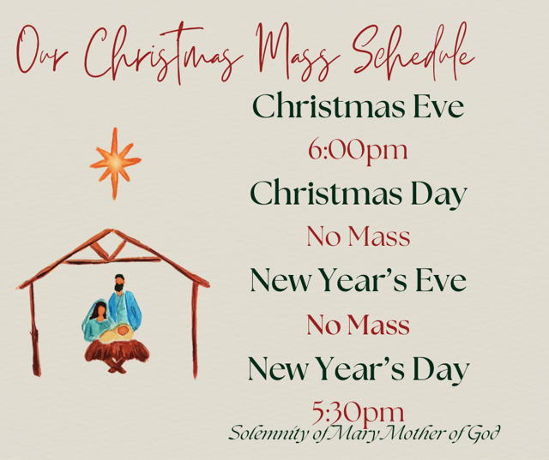


AREA CHRISTMAS MASS SCHEDULES:
St. Patrick’s (Clear Lake): Christmas Eve 4:00pm; Christmas Day 10:00am.
Epiphany (Mason City): Christmas Eve 4:00pm (St. Joseph’s and Holy Family) and 6:00pm (St. Joseph’s); Christmas Day 9:00am (Holy Family) and 10:30am (Spanish Mass at Holy Family)

